**CSE3011 NETWORK PROGRAMMING**

**LAB EXPERIMENT 3**

NAME – B PRATYUSH

REGISTRATION NUMBER – 19BCN7114

LAB SLOT – L43+L44

FACULTY – PROF. MUNEESWARI

**Experiment Description: Remote Method Invocation (RMI)**

**Codes:**

**RMIServInt.java (Server Interface Class)**

import java.rmi.*;

import java.rmi.server.*;

public interface RMIServInt extends Remote{

public double sum(double n1, double n2) throws RemoteException;

}

**RMIServImpl.java (Server Implementation Class)**

import java.rmi.*;

import java.rmi.server.*;

public class RMIServImpl extends UnicastRemoteObject implements RMIServInt{

public RMIServImpl() throws RemoteException

{

super();

}

public double sum(double n1, double n2) throws RemoteException{

return n1+n2;

}

}

**RMIServer.java (Server Class)**

import java.rmi.*;

import java.rmi.server.*;

import java.rmi.registry.*;

public class RMIServer extends RMIServImpl{

public RMIServer() throws RemoteException

{

}

public static void main(String args[]) throws RemoteException{

try

{

Registry registry= LocateRegistry.createRegistry(5000);

RMIServImpl serv = new RMIServImpl();

registry.rebind("rmiServer",serv);

System.out.println("SERVER operation completed!");

}

catch(Exception e)

{

System.out.println(e);

}

}

}

**RMIClient.java (Client class)**

import java.rmi.server.*;

import java.rmi.registry.*;

public class RMIClient{

public static void main(String[]args) throws RemoteException{

try

{

double n1 = Double.parseDouble(args[0]);

double n2 = Double.parseDouble(args[1]);

Registry registry = LocateRegistry.getRegistry("127.0.0.1",5000);

RMIServInt a = (RMIServInt)registry.lookup("rmiServer");

System.out.println("First number value: "+n1);

System.out.println("Second number value: "+n2);

System.out.println("Sum of the two numbers:\t"+a.sum(n1,n2));

}

catch(Exception e)

{

System.out.println(e);

}

}

}

**Output:**

1. **Generating stub using rmic command on server implementation class**
2. **Then starting the rmi registry using start rmiregistry command**

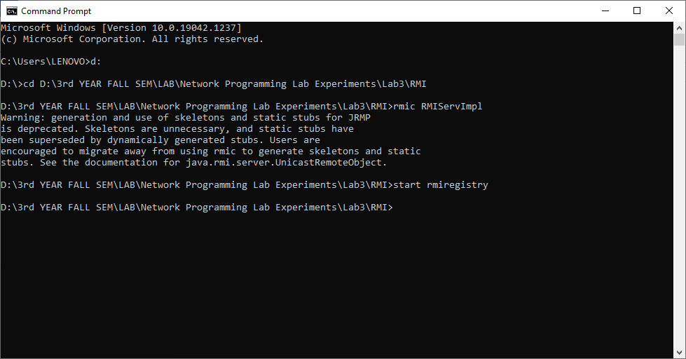

1. **Compile and execute the server class in another command prompt**

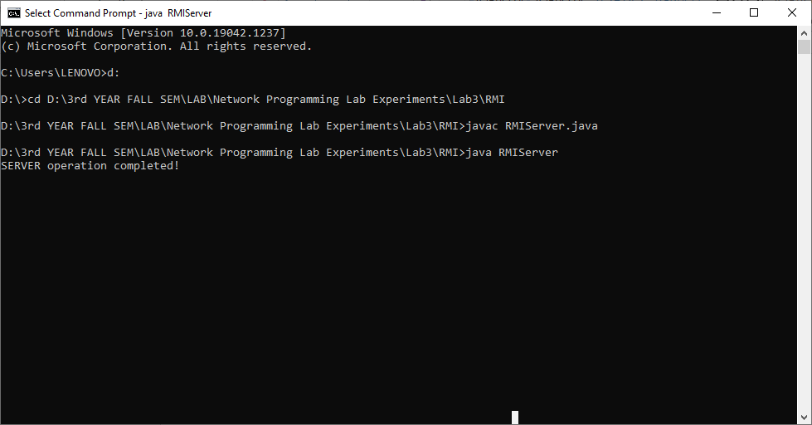

1. **Then compile and execute the Client class in another command prompt**

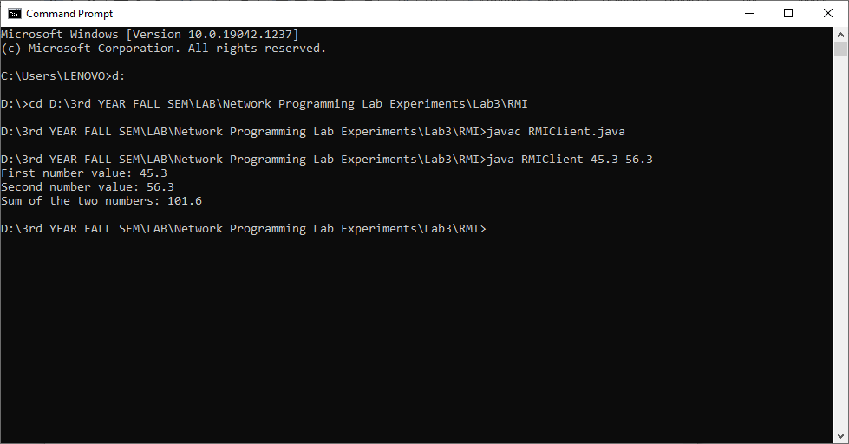

1. **Stub class is present in folder or not.**

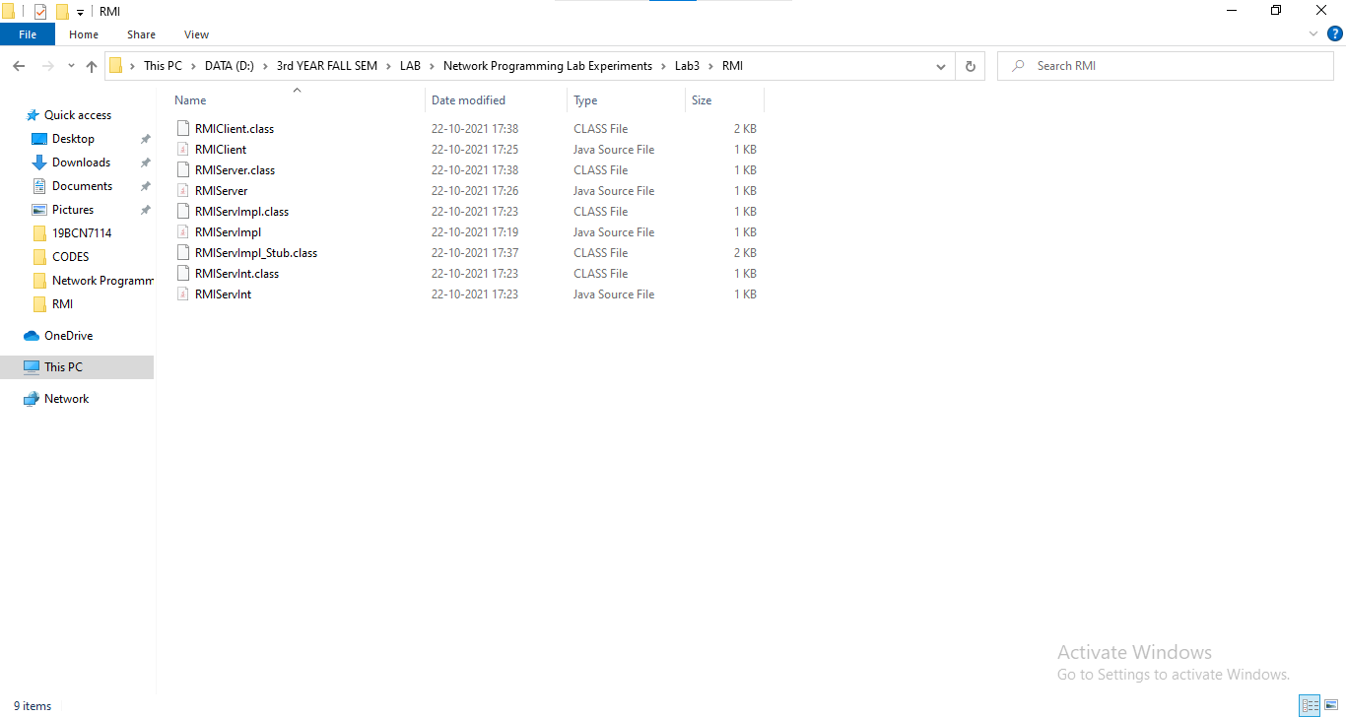

**RMIServImpl_Stub.class is the stub class.**